**Assignment – 4**

**Python Basics**

Name: Venkatagiriraju U

NM Id: au611220104310

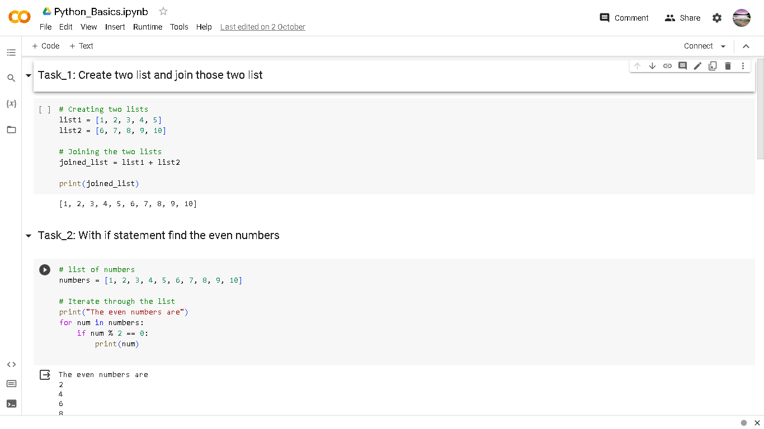

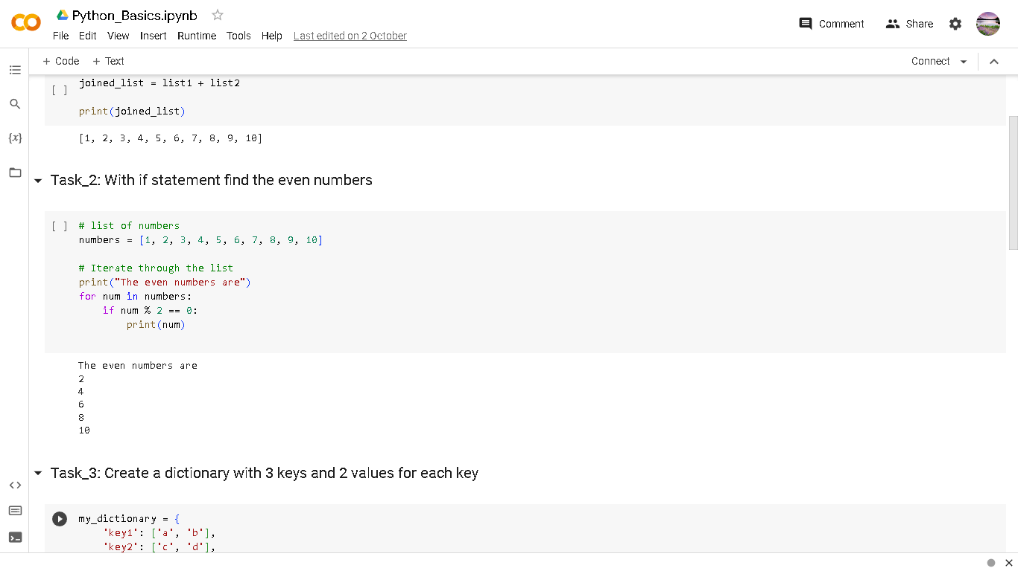

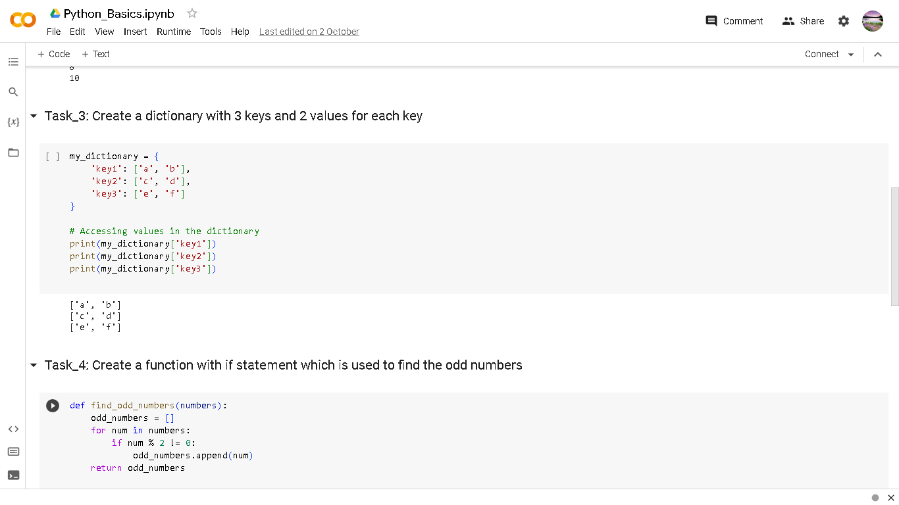

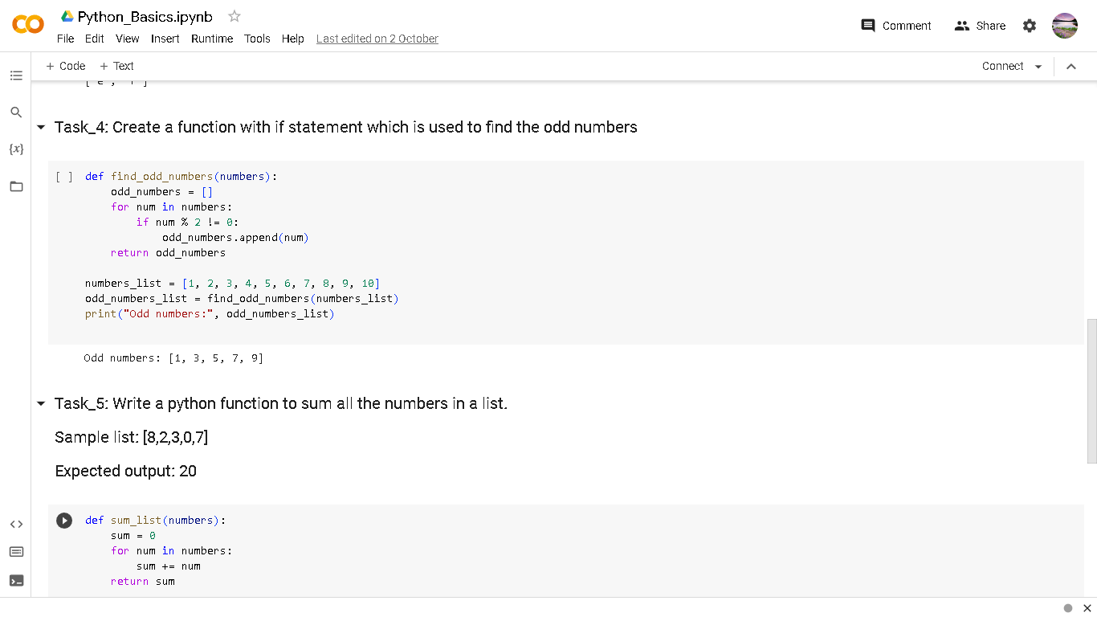

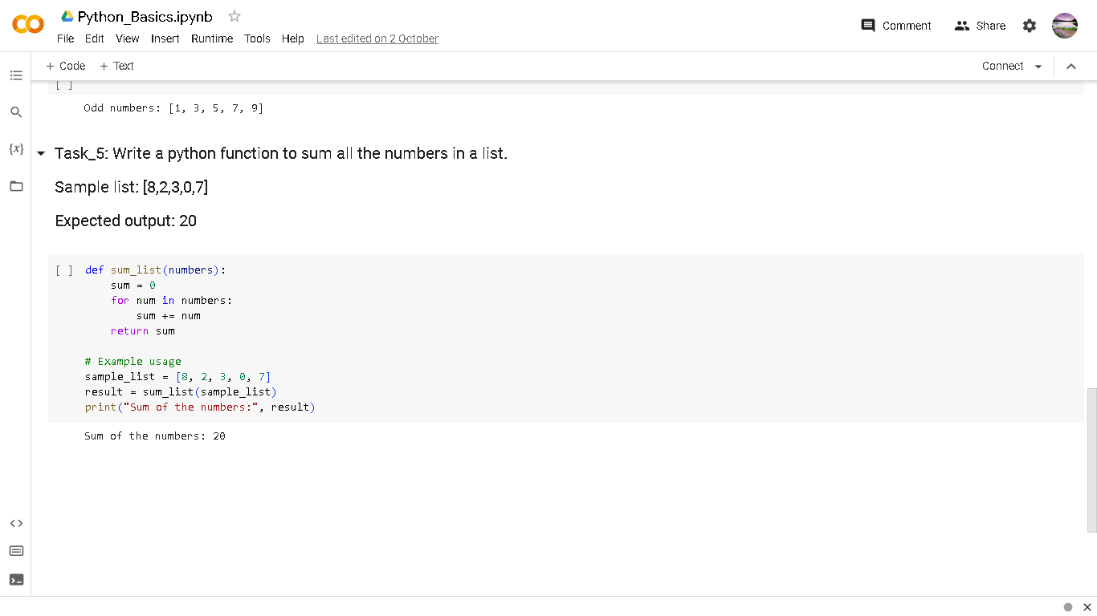

Python file link:

https://colab.research.google.com/drive/1VA73_yIN_gASZh7IGR6Gnehux4iu31Xa?usp=sharing